Tax Reliefs.docx
- Parenthood Tax Rebate
Qualifying for rebate
https://www.iras.gov.sg/taxes/individual-income-tax/basics-of-individual-income-tax/tax-reliefs-rebates-and-deductions/tax-reliefs/parenthood-tax-rebate-(ptr)
PTR is given to tax residents to encourage them to have more children.
To qualify, you must be a Singapore tax resident who is married, divorced or widowed in the relevant year.
You may use the PTR Eligibility Tool (XLSM, 67KB) to check your eligibility for PTR.
Children born or adopted on or after 1 Jan 2008
S/N  1 | Conditions for qualifying child  - Born to you and your spouse/ex-spouse on or after 1 Jan 2008 and you are married to your spouse/ex-spouse at the time; and  - Is a Singapore Citizen* at the time of birth or within 12 months thereafter | Relevant year of claim  Year of birth
S/N  2 | Conditions for qualifying child  - Born to you and your spouse/ex-spouse on or after 1 Jan 2008 before you are married to your spouse/ex-spouse, and your marriage is registered before your child reaches 6 years old; and  - Is a Singapore Citizen* at the time of your marriage or within 12 months thereafter | Relevant year of claim  Year of marriage
S/N  3 | Conditions for qualifying child  - Legally adopted on or after 1 Jan 2008 when you are married but before your child reaches 6 years old; and  - Is a Singapore Citizen* at the time of legal adoption or within 12 months thereafter | Relevant year of claim  Year of adoption
* You may qualify for PTR for children born overseas if you meet the qualifying conditions, including the stipulated timeline for the child to obtain Singapore Citizenship. For information on applying for Singapore Citizenship, please visit the Immigration and Checkpoints Authority (ICA) website.
Children born or adopted before 1 Jan 2008
PTR is not available in respect of your 1st child born or adopted before 1 Jan 2008. Your 2nd, 3rd or 4th child must meet the following conditions to qualify for PTR.
S/N  1 | Conditions for qualifying child  - Born to you and your spouse/ex-spouse on or after 1 Jan 2004 and you are married to your spouse/ex-spouse at the time; and  - Is a Singapore Citizen* at the time of birth or within 12 months thereafter | Relevant year of claim  Year of birth
S/N  2 | Conditions for qualifying child  - Born to you and your spouse/ex-spouse on or after 1 Jan 2004 before you are married to your spouse/ex-spouse, and your marriage is registered before your child reaches 6 years old; and  - Is a Singapore Citizen* at the time of your marriage or within 12 months thereafter | Relevant year of claim  Year of marriage
S/N  3 | Conditions for qualifying child  - Legally adopted on or after 1 Jan 2004 but before 1 Jan 2006; or  - Legally adopted on or after 1 Jan 2006 but before the child reaches 6 years old; and  - Is a Singapore Citizen* at the time of legal adoption or within 12 months thereafter | Relevant year of claim  Year of adoption
*You may qualify for PTR for children born overseas if you meet the qualifying conditions, including the stipulated timeline for the child to obtain Singapore Citizenship. For information on applying for Singapore Citizenship, please visit the ICA website.
PTR treatment for different scenarios
ScenariosPTR for children given up for adoption | PTR treatment  - When the child is given up for adoption in the year of birth  Parents are not entitled to any PTR on the child.  - When the child is given up for adoption after the year of birth  Parents are not entitled to PTR once the child is given up for adoption. The remaining PTR balance is forfeited. For instance, if the child is given up for adoption in 2025, the parents are no longer entitled to claim any unutilised PTR balance from YA 2026.
ScenariosIf marriage is dissolved under a court order | PTR treatmentYou and your ex-spouse may continue to utilise any credit balance remaining in your respective PTR accounts to offset future tax liabilities.
ScenariosIf one spouse passes away | PTR treatmentYou may continue to utilise any credit balance remaining in your respective PTR accounts to offset future tax liabilities.
Determining child order
The amount of PTR varies for each child based on the child order in the family unit.
For PTR purpose, no child will be considered as a member of 2 households. Children from a previous marriage will be included in the family unit of 1 parent after taking into consideration the rights of custody, care and control and the living arrangements of the child, in order of priority.
Any sibling who is deceased / a stillborn^ child will be counted in determining the number of siblings a child has at the time of his/her birth, adoption, or marriage of his/her parents, as the case may be.
^This is applicable for PTR claim effective from the YA 2022 (or a subsequent YA), and where the natural mother of the stillborn child is a member of the same household of the child in respect of whom PTR is being claimed.
The order of your child for PTR is based on:
For a child born to you and your spouse/ex-spouse | Date of birth shown in your child's birth certificate
For a child born to you and your spouse/ex-spouse before you are married to your spouse/ex-spouse | Date of marriage
For a step-child | Date of birth shown in your child's birth certificate
For a legally adopted child | Date of legal adoption as shown in the adoption papers
Amount of rebate
You and your spouse may share the PTR based on an apportionment agreed by both of you. If your percentage of PTR claimed does not add up to 100% or you are unable to agree on the apportionment, we will apportion the PTR equally between the both of you.
Child order1st | PTR  (For child born in 2004 to 2007)$0 | PTR  (For child born from 2008 onwards)$5,000
Child order2nd | PTR  (For child born in 2004 to 2007)$10,000 | PTR  (For child born from 2008 onwards)$10,000
Child order3rd | PTR  (For child born in 2004 to 2007)$20,000 | PTR  (For child born from 2008 onwards)$20,000
Child order4th | PTR  (For child born in 2004 to 2007)$20,000 | PTR  (For child born from 2008 onwards)$20,000
Child order5th and subsequent child | PTR  (For child born in 2004 to 2007)$0 | PTR  (For child born from 2008 onwards)$20,000 per child

Example 1: Claiming PTR and Working Mother's Child Relief (WMCR)

Carrying forward unutilised PTR
Any unutilised amount will automatically be carried forward to offset your future income tax payable. Any remaining balance is not refundable.
Viewing/ Transferring unutilised PTR to your spouse
To view your PTR balance or transfer your unutilised PTR balance to your spouse, please use the 'View/ Transfer Parenthood Tax Rebate (PTR)' digital service at myTax Portal. The transferred PTR amount will be used to offset your spouse's income tax payable for the current YA, if applicable.
How to claim
e-Filing
Is this the first time you are claiming the rebate?
Yes  - Log in to myTax Portal using your Singpass or Singpass Foreign user Account (SFA).  - Go to “Individuals” > “File Income Tax Return”.  - Select “File” to File Income Tax Return.  - Go to “4. Deductions, Tax Reliefs and Rebates”.  - Select “Add New” > “Child/Parenthood Tax Rebate”.  - Fill in the relevant information and select “Yes” under “Claim one-time Parenthood Tax Rebate (PTR)” to indicate share of PTR as agreed by you and your Spouse.  - Select "Update". | No  Any unutilised balance in your PTR account will automatically be applied to offset your tax payable once your tax bill has been finalised.  You may view your PTR balance under 'View/ Transfer Parenthood Tax Rebate (PTR)' digital service at myTax Portal using your Singpass or Singpass Foreign user Account (SFA).

Paper filing
Is this the first time you are claiming the rebate?
Yes  Form B1 & B  Complete the particulars of your child in Appendix 2. | No  Form B1 & B  Any unutilised balance is automatically carried forward to offset your future tax payable.  You may view your PTR balance under 'View/ Transfer Parenthood Tax Rebate (PTR)' digital service at myTax Portal using your Singpass or Singpass Foreign user Account (SFA).
FAQs
Collapse all

What should I do if the Parenthood Tax Rebate (PTR) account has not been created for my child?

Before receiving your tax assessment:
1. If you e-Filed your Income Tax Return
If the PTR account has not been created for your child, please follow the steps under 'How to Claim'. You may re-file once by 18 Apr. When you re-file, you must include all your income details, expenses, donations and relief claims, where applicable. Once you have re-filed successfully, your new submission will override the previous submission.
2. If you filed a paper Income Tax Return or are unable to re-file online
Please file an amendment upon receiving your tax bill for the current YA. You may file the amendment via the 'Amend Tax Bill' digital service at myTax Portal within 30 days from the date of your Income Tax bill.
After receiving your tax assessment:
If the PTR account has not been created for your child, you may file the amendment via the 'Amend Tax Bill' digital service at myTax Portal within 30 days from the date of your Income Tax bill.

Our child is born in 2025. However, both my spouse and I have very little income in 2025 and do not need to pay tax for YA 2026. Do we still need to claim the PTR for YA 2026?

Although you and your spouse do not need to use the PTR to offset against any income tax for YA 2026, we would encourage you to make a claim during your tax filing. This would allow the PTR to be automatically offset against the income tax payable by you or your spouse in future years.

I have made a 100% claim for PTR for my first child born in 2024 and some PTR has been utilised to offset against my income tax payable for YA 2025. The balance in the PTR account was utilised to partially offset my income tax payable for YA 2026. Will IRAS top-up my PTR account with another $5,000 in YA 2026?

PTR is a one-off rebate given only once in the YA immediately following the year of birth of your child. If you are unable to fully utilise the rebate in that YA, you may carry forward the balance of the rebate to offset your tax liability in the future YAs or until it is fully utilised.
There will not be any top-up of the PTR account in respect of the same child.

My spouse has just transferred her PTR balance to me for YA 2026. Do I need to make a claim for PTR in my YA 2026 Income Tax Return?

You are not required to make the PTR claim in your Income Tax Return. The PTR that has been transferred to your account will be automatically used to offset your income tax payable for the current YA.
If you have already paid your Income Tax for the current YA, your tax assessment for the current year will be revised automatically within 10 working days and any excess payment after using the PTR will be refunded to you automatically.

- Parent Relief
Parent Relief/Parent Relief (Disability)
https://www.iras.gov.sg/taxes/individual-income-tax/basics-of-individual-income-tax/tax-reliefs-rebates-and-deductions/tax-reliefs/parent-relief-parent-relief-(disability)
Parent Relief/Parent Relief (Disability) is given to promote filial piety and recognise individuals who are supporting their parents, grandparents, parents-in-law or grandparents-in-law in Singapore.
To claim Parent Relief/Parent Relief (Disability) for the Year of Assessment (YA) 2026, you must satisfy all these conditions in 2025:
- You have supported your dependant (e.g. Parents/Parents-in-law/Grandparents/Grandparents-in-law/Step-parents/Step-grandparents/Adoptive parents/Adoptive grandparents);
- ^Your dependant was 55 years of age or above;
- ^Your dependant did not have an annual income& of more than $8,000! in year 2025; and
- Your dependant was:
a. living with you in the same household in Singapore#; or
b. living in a separate household in Singapore and you have incurred $2,000 or more in supporting him/her.
^The condition does not apply if claiming Parent Relief (Disability) for a physically disabled or mentally impaired dependant.
&Annual income includes the following:
a. taxable income (e.g. trade, employment, rental and SRS withdrawals);
b. tax-exempt income (e.g. bank interest, dividends and pensions) with the exception of CPF payouts; and
c. foreign-sourced income (regardless of whether it has been remitted to Singapore).
!From the YA 2025, the annual income threshold of $4,000 has been increased to $8,000. However, for YA 2024 and before, the annual income threshold of $4,000 will remain. There is no change to the other conditions.
#"Living in Singapore" means the dependant resided permanently in Singapore in 2025, with only temporary absences (e.g. short vacations). For foreign dependants, this generally applies if they stayed for at least 8 months in 2025.
Amount of relief
Type of Parent ReliefTaxpayer stays with dependant | Parent Relief$9,000 per dependant | Parent Relief (Disability)$14,000 per dependant
Type of Parent ReliefTaxpayer does not stay with dependant | Parent Relief$5,500 per dependant | Parent Relief (Disability)$10,000 per dependant

Number of dependants to claim
You may claim Parent Relief/Parent Relief (Disability) for up to 2 dependants.
Sharing of relief claims
If more than one individual is maintaining the same dependant and meets the qualifying conditions, the Parent Relief/Parent Relief (Disability) may be shared between the claimants based on an agreed apportionment.
However, if you are claiming for Parent Relief/Parent Relief (Disability), no other claimant will be allowed to claim the following on the same dependant. For example, if your father has claimed spouse relief on your mother, you and your other siblings will not be able to claim parent relief in respect of your mother. Please discuss with your other family members / co-claimants on the type and amount of relief to be claimed on a dependant.
An exception is only for working mothers who may claim Grandparent Caregiver Relief and Parent Relief / Parent Relief (Disability) on the same dependant if the qualifying conditions are met.
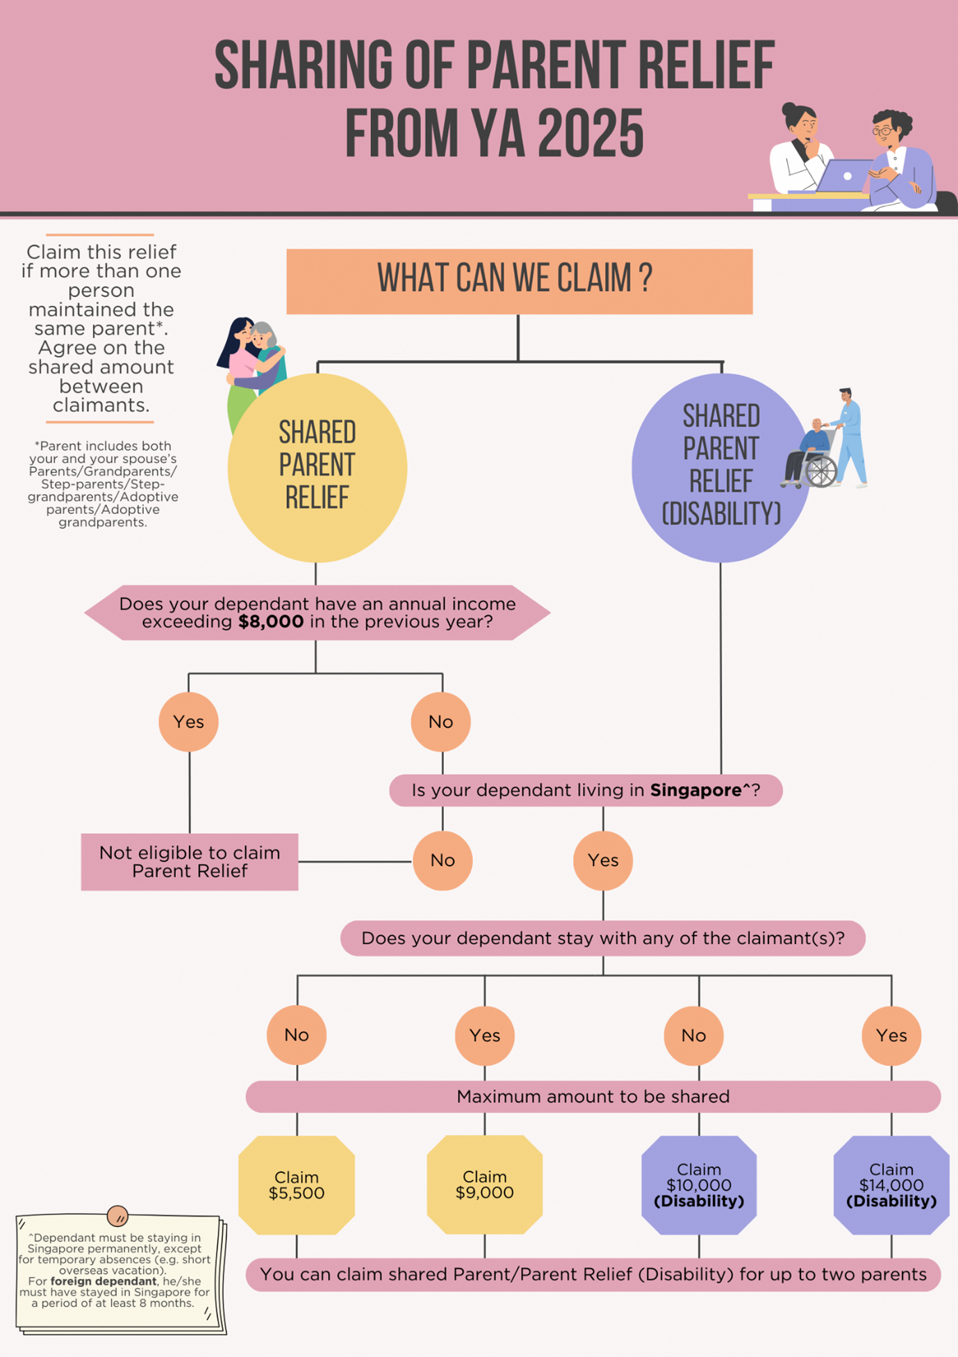

Example 1: Claiming Parent Relief and Spouse Relief on the same dependant

Example 2: Sharing of Parent Relief/Parent Relief (Disability)

Claiming relief on a deceased parent
You may still claim the full amount of relief in the YA 2026 even when the dependant has passed away in the previous year (2025), provided you have satisfied all the qualifying conditions.
However, you will not be able to claim Parent Relief/Parent Relief (Disability) on the same dependant from the following year onwards (i.e. YA 2027).
How to claim
e-Filing
Is this the first time you are claiming the relief?
Yes  - Log in to myTax Portal using your Singpass or Singpass Foreign user Account (SFA).  - Go to “Individuals” > “File Income Tax Return”.  - Select “File” to File Income Tax Return.  - Go to “4. Deductions, Tax Reliefs and Rebates”.  - Select “Add New” > “Parent”.  - Fill in the relevant information and select “Update". | No  If the relief has been allowed to you last year, the amount will be pre-filled and granted to you automatically this year.  Follow the steps on the left if you need to make any changes to your relief.

Paper filing
Is this the first time you are claiming the relief?
Yes  Form B1 & B  - Complete the item on “Parent/Parent Relief (Disability)”.  - Complete the particulars of your dependant(s) in Appendix 2. | No  Form B1 & B  Complete the item on “Parent/Parent Relief (Disability)”.
First-time Parent Relief (Disability) claims
Parent Relief (Disability) may be allowed if:
S/N  1. | Eligibility  Your dependant requires assistance in any one of the 6 Activities of Daily Living (ADLs) for physical disability*:  *(1) Washing or Bathing, (2) Dressing, (3) Feeding, (4) Toileting, (5) Transferring and (6) Mobility; or | Details, Details  Making first-time claim  If you are claiming Parent Relief (Disability) for the first time, please retain the relevant supporting documents indicating the disability details and commencement date, and submit them only when requested by IRAS, for example:  - Letter/ supporting documents from the disability association; or  - Medical report or doctor’s certification; or  - Completed Application for Claim of Disability Related Tax Reliefs (DOC, 413KB).
S/N  2. | Eligibility  Your dependant is impaired in any one of the 3 areas of activities for mental impairment^:  ^(1) Self Care and Activities of Daily Living, (2) Compliance to Psychiatric Treatment and (3) Education or Work
If you no longer satisfy the conditions for Parent Relief (Disability) (e.g. your dependant recovers from his/her condition), please withdraw the claim from your Income Tax Return if the relief has been auto-included for you as per your previous year’s assessment.
Expand all

- cal disability – 6 ADLs

- Washing or bathing: Ability to bathe or shower (including getting into and out of the bath or shower) or wash by other means.
- Dressing: Ability to put on, take off, secure and unfasten all garments (upper and lower) and any braces, artificial limbs or other surgical appliances.
- Feeding: Ability to feed oneself after food has been prepared and made available.
- Toileting: Ability to use the toilet or manage bowel and bladder function through the use of protective undergarments or appropriate surgical appliances.
- Transferring: Ability to move from (a lying position on the) bed to an upright chair or wheelchair, and vice versa.
- Mobility: Ability to move indoors from room to room on level surfaces.

- ^Mental Impairment – 3 areas of activities

- Self Care and Activities of Daily Living: Ability to care for self and independently manage activities of daily living (i.e., washing/bathing, dressing, feeding, toileting, transferring and mobility).
- Compliance to psychiatric treatment: Ability to take medications and comply with prescribed psychiatric treatments.
- Education or work: Ability to integrate into the normal stream of education or to sustain gainful employment.
- FAQs

- I have filed my Income Tax Return but have yet to receive my tax bill for the current YA. What should I do if I have forgotten to claim, or need to amend my claim for Parent Relief/Parent Relief (Disability)?

- 1. If you e-Filed your Income Tax Return
- You may re-file once by 18 Apr. When you re-file, you must include all your income details, expenses, donations and relief claims, where applicable. Once you have re-filed successfully, your new submission will override the previous submission.
- 2. If you filed a paper Income Tax Return or are unable to re-file online
- Please file an amendment upon receiving your tax bill for the current YA. You may file the amendment via the 'Amend Tax Bill' digital service at myTax Portal within 30 days from the date of your Income Tax bill.

- I have received my tax bill for the current YA. What should I do if I need to amend my claim for Parent Relief/Parent Relief (Disability)?

- Please file an amendment using the 'Amend Tax Bill' digital service at myTax Portal within 30 days from the date of your tax bill.
- First-time Parent Relief (Disability) claims
- Please refer to the information provided under the topic on “First-time Parent Relief (Disability) claims”.

- I have received my tax bill for the current YA. It shows that I have been given Parent Relief on my mother. However, I would want my sister to claim the relief on my mother this time. What should I do?

- You and your sister should file an amendment using the 'Amend Tax Bill' digital service at myTax Portal within 30 days from the date of your respective tax bills.

- My father has been living with me since last year. However, he was hospitalised in Singapore for a few months in that year. Is he considered to be living in the same household as me for the previous year? Can I claim Parent Relief of $9,000 for the current YA?

- Yes, your father is considered to be living in the same household as you for the previous year. You may claim Parent Relief of $9,000 for the current YA if you have met the other qualifying conditions.
- Generally, when the dependant stays with you before and after hospitalisation in Singapore during the previous year, the dependant would be considered to have lived in the same household as you in that year.
- If the dependant has passed away during the hospital stay in Singapore and has lived with you before hospitalisation in the previous year, the dependant would also be considered to have lived in the same household as you in that year.

- My mother has been living in a nursing home in Singapore in the previous year. Is she considered to be living in the same household as me in that year? Can I claim Parent Relief on her for the current YA?

- No, your mother is not considered to be living with you in the same household in the previous year. However, you may claim Parent Relief of $5,500 on your mother for the current YA if you have met the other qualifying conditions.

- Spouse Relief
Spouse Relief/ Spouse Relief (Disability)
Share:
Spouse Relief/Spouse Relief (Disability) recognises both male and female taxpayers who have supported their spouses.
On this page:FAQs

Qualifying for relief
To claim Spouse Relief for the Year of Assessment (YA) 2026, you must satisfy all these conditions in 2025:
1. Your spouse was living with/supported by you; and

2. ^Your spouse did not have an annual income& of more than $8,000! in year 2025.

^The condition will not be applicable if you will wish to claim for Spouse Relief (Disability) and the dependant is physically disabled or mentally impaired.
&Annual income includes the following:
a. taxable income (e.g. trade, employment, rental and SRS withdrawals);
b. tax-exempt income (e.g. bank interest, dividends and pensions) with the exception of CPF payouts; and
c. foreign-sourced income (regardless of whether it has been remitted to Singapore).
!From the YA 2025, the annual income threshold of $4,000 has been increased to $8,000. However, for YA 2024 and before, the annual income threshold of $4,000 will remain. There is no change to the other conditions.
Legally separated spouses
If you are legally separated from your spouse*, you may claim this relief if you have made maintenance payments under a Court Order or Deed of Separation.
- *For YA 2025 and before, Spouse Relief and Spouse Relief (Disability) only cover maintenance payments that legally separated husbands make to their wives under a court order or a deed of separation.
- From YA 2026 onwards, Spouse Relief and Spouse Relief (Disability) are expanded to cover maintenance payments that legally separated wives make to their husbands under a court order or a deed of separation.
Divorced spouses
Divorced taxpayers who pay alimony to their former spouses are not eligible to claim this relief.
Amount of relief
Spouse Relief$2,000 | Spouse Relief (Disability)$5,500 | Legally separated spouses ordered to make maintenance payments under a Court Order or Deed of SeparationLower of:  - Maintenance payments in the previous year;  - $2,000 for wife; or  - $5,500 for wife with disability
Other relief claims on your spouse
If you are claiming for Spouse Relief/Spouse Relief (Disability), no other claimant is allowed to claim the following on your spouse:
- Parent Relief/Parent Relief (Disability) (except Grandparent Caregiver Relief)
- Sibling Relief (Disability)

Example 1: Claiming Spouse Relief and Parent Relief on the same dependant

Mrs Soh has supported her husband and is eligible to claim Spouse Relief.
Their child, Kylie, has also supported her father and is also eligible to claim Parent Relief.
If Mrs Soh has claimed Spouse Relief, Kylie will not be able to claim Parent Relief in the same YA.
How to claim
e-Filing
Is this the first time you are claiming the relief?
Yes  - Log in to myTax Portal with your Singpass or Singpass Foreign user Account (SFA).  - Go to “Individuals” > “File Income Tax Return”.  - Select “File” to File Income Tax Return.  - Go to “4. Deductions, Tax Reliefs and Rebates”.  - Select “Add New” > “Spouse”.  - Fill in the relevant information and select “Update”. | No  If the relief has been allowed to you last year, the amount will be pre-filled and granted to you automatically this year.  Follow the steps on the left if you need to make any changes to your relief.

Paper filing
Is this the first time you are claiming the relief?
Yes  Form B1 & B  - Complete the item on “Spouse/Spouse Relief (Disability)”.  - Complete the particulars of your spouse in Appendix 2. | No  Form B1 & B  Complete the item on “Spouse/Spouse Relief (Disability)”.
First-time Spouse Relief (Disability) claims
Spouse Relief (Disability) may be allowed if:
S/N  1. | Eligibility  Your spouse requires assistance in any one of the 6 Activities of Daily Living (ADLs) for physical disability*:  *(1) Washing or Bathing, (2) Dressing, (3) Feeding, (4) Toileting, (5) Transferring and (6) Mobility; or | Details, Details  Making first-time claim  If you are claiming Spouse Relief (Disability) for the first time, please retain the relevant supporting documents indicating the disability details and commencement date, and submit them only when requested by IRAS, for example:  - Letter/ supporting documents from the disability association; or  - Medical report or doctor’s certification; or  - Completed Application for Claim of Disability Related Tax Reliefs (DOC, 413KB).
S/N  2. | Eligibility  Your spouse is impaired in any one of the 3 areas of activities for mental impairment^:  ^(1) Self Care and Activities of Daily Living, (2) Compliance to Psychiatric Treatment and (3) Education or Work
If you no longer satisfy the conditions for Spouse Relief (Disability) (e.g. your spouse recovers from his/her condition), please withdraw the claim from your Income Tax Return if the relief has been auto-included for you as per your previous year’s assessment.
Collapse all

*Physical disability – 6 ADLs

- Washing or bathing: Ability to bathe or shower (including getting into and out of the bath or shower) or wash by other means.
- Dressing: Ability to put on, take off, secure and unfasten all garments (upper and lower) and any braces, artificial limbs or other surgical appliances.
- Feeding: Ability to feed oneself after food has been prepared and made available.
- Toileting: Ability to use the toilet or manage bowel and bladder function through the use of protective undergarments or appropriate surgical appliances.
- Transferring: Ability to move from (a lying position on the) bed to an upright chair or wheelchair, and vice versa.
- Mobility: Ability to move indoors from room to room on level surfaces.

^Mental Impairment – 3 areas of activities

- Self Care and Activities of Daily Living: Ability to care for self and independently manage activities of daily living (i.e., washing/bathing, dressing, feeding, toileting, transferring and mobility).
- Compliance to psychiatric treatment: Ability to take medications and comply with prescribed psychiatric treatments.
- Education or work: Ability to integrate into the normal stream of education or to sustain gainful employment.

I have filed my Income Tax Return but have yet to receive my tax bill for the current YA. What should I do if I have forgotten to claim, or need to amend my claim for Spouse Relief/Spouse Relief (Disability)?

1. If you e-Filed your Income Tax Return
You may re-file once by 18 Apr. When you re-file, you must include all your income details, expenses, donations and relief claims, where applicable. Once you have re-filed successfully, your new submission will override the previous submission.
2. If you filed a paper Income Tax Return or are unable to re-file online
Please file an amendment upon receiving your tax bill for the current YA. You may file the amendment via the 'Amend Tax Bill' digital service at myTax Portal within 30 days from the date of your Income Tax bill.
3. First-time Spouse Relief (Disability) claims
Please refer to the information provided under the topic on “First-time Spouse Relief (Disability) claims”.

I have received my tax bill for the current YA. What should I do if I need to amend my claim for Spouse Relief/Spouse Relief (Disability)?

Please file an amendment using the 'Amend Tax Bill' digital service at myTax Portal within 30 days from the date of your tax bill.
First-time Spouse Relief (Disability) claims
Please refer to the information provided under the topic on “First-time Spouse Relief (Disability) claims”.

- Qualifying Child Relief
Qualifying Child Relief (QCR)/ Child Relief (Disability)
Share:
Qualifying Child Relief (QCR) and Child Relief (Disability) are given to parents to recognise their efforts in supporting their children.
On this page:Related Content
Qualifying for relief
To claim Qualifying Child Relief (QCR)/Child Relief (Disability) for the Year of Assessment (YA) 2026, you must satisfy all these conditions in 2025:
1. Your child is unmarried and was/is:
a. Born to you and your spouse/ex-spouse; or
b. Is a step-child; or
c. Is legally adopted

2. ^Your child was:
a. Below 16 years old; or
b. 16 years old or above studying full – time at any university, college or other educational institution at any time in the year

3. ^Your child did not have an annual income& exceeding $8,000!
4. You have been maintaining your child
^The condition will not be applicable if you will wish to claim for Child Relief (Disability) and the child is physically disabled or mentally impaired.
&Annual income includes allowances and salaries from National Service, internship, school attachment and part-time employment. It does not include scholarships, bursaries and similar allowances.
!From YA 2025, the annual income threshold of $4,000 has been increased to $8,000. However, for YA 2024 and before, the annual income threshold of $4,000 will remain. There is no change to the other conditions.

Example 1: Child is above 16 years old and received an annual income exceeding $8,000

Mr Tan's daughter, Bernice was 18 years old and a full-time student in 2025. She did some part time work from Feb to Aug 2025 and earned an employment income of $9,000 for that period.
Mr Tan will not be eligible to claim for QCR in respect of Bernice in YA 2026 as her income for 2025 exceeded $8,000.
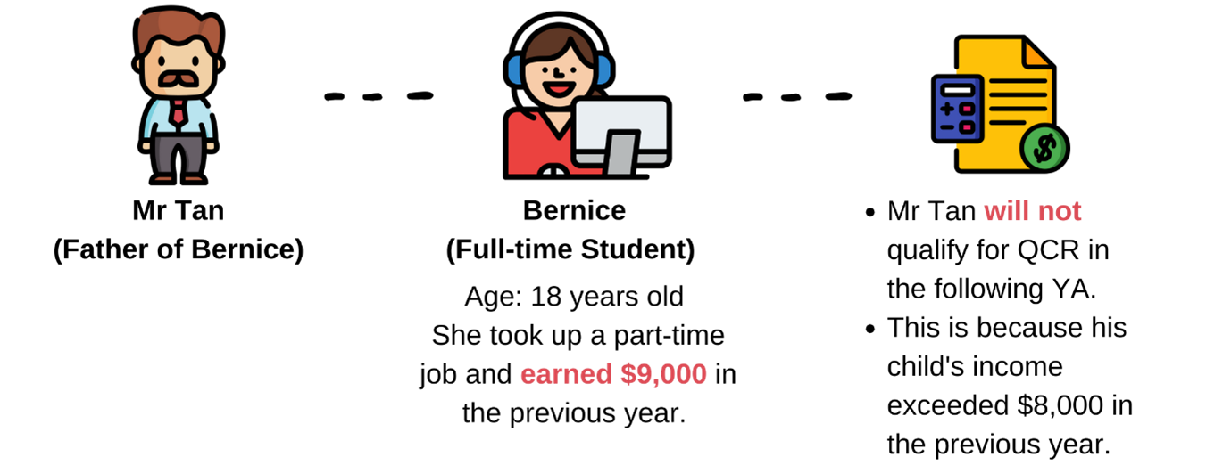

Example 2: Child serving or completed National Service (NS) and starting full-time studies

Mr and Mrs Koh have a son, Andy, who served full-time NS for the whole year in 2024.
Andy completed his NS in Mar 2025 and started his full-time university studies in Jul 2025. He received $3,000 in NS allowance and had no other income in 2025.
Mr and Mrs Koh’s eligibility for QCR is as follows:
YA 2025 | Not eligible to claim QCR as Andy was not studying full-time in 2024.
YA 2026 | Eligible to claim QCR as Andy was studying full-time in 2025 and did not have an annual income exceeding $8,000.
Determining child order
The order of your child in the family unit is based on:
For a child born to you and your spouse/ex-spouse | Date of birth shown in your child's birth certificate
For a child born to you and your spouse/ex-spouse before you are married to your spouse/ex-spouse | Date of marriage
For a step-child | Date of birth shown in your child's birth certificate
For a legally adopted child | Date of legal adoption as shown in the adoption papers
A deceased / stillborn child is counted in determining the order of children.
Amount of relief
Qualifying Child Relief (QCR)$4,000 per child | Child Relief (Disability)$7,500 per child
If you are a working mother and have met all the conditions for Working Mother’s Child Relief (WMCR), you may claim QCR/Child Relief (Disability) and WMCR on the same child.
- QCR/Child Relief (Disability)+ WMCR is capped at $50,000 per child.
- QCR/Child Relief (Disability), regardless of whether it is claimed by the father or mother, will be allowed first. WMCR will be limited to the remaining balance.
Sharing of relief on the same child
You may share the QCR/Child Relief (Disability) on the same child with your spouse/ex-spouse based on an agreed apportionment.
When you share the QCR/Child Relief (Disability) with your spouse/ex-spouse, the total claim amounts must not exceed $4,000 (QCR) and $7,500 (Child Relief (Disability)) for each child.
Collapse all

Example 3: Sharing Child Relief (Disability) on a child with disability

Mr and Mrs Ow have a child with disability and they have agreed to share the Child Relief (Disability) of $7,500.
Based on their agreed apportionment, Mr Ow and Mrs Ow will claim $3,500 and $4,000 respectively.
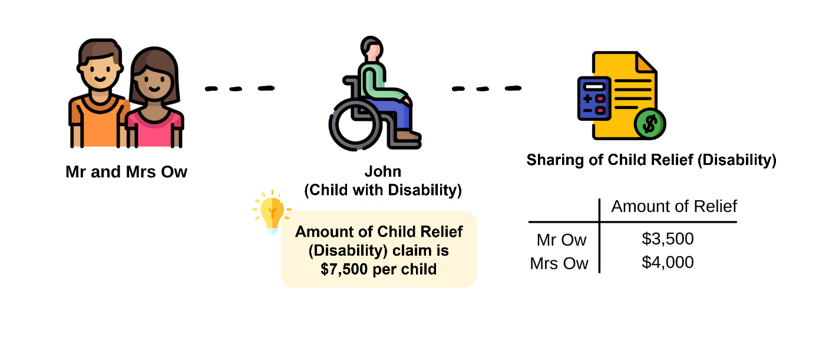

Example 4: Claiming QCR and WMCR for child born before 1 Jan 2024, capped at $50,000 per child

Mr and Mrs Lim have an only child, Hilary, who was 10 years old in 2025. Mrs Lim has an earned income of $320,000 for that year.
They decided that Mr Lim would claim the full amount of QCR of $4,000.
For YA 2026:
Type of reliefQCR claimed by Mr Lim | Amount of relief$4,000
Type of reliefWMCR claimed by Mrs Lim | Amount of reliefAmount of WMCR for first child  = 15% of Mrs Lim’s earned income  = 15% of $320,000  = $48,000  As the maximum relief claim allowed for a child is $50,000, the amount of WMCR allowed will be $46,000 ($50,000 - $4,000).
Type of reliefTotal amount of relief claimed on Hilary by Mr Lim and Mrs Lim | Amount of relief$4,000 (QCR) + $46,000 (WMCR)  = $50,000
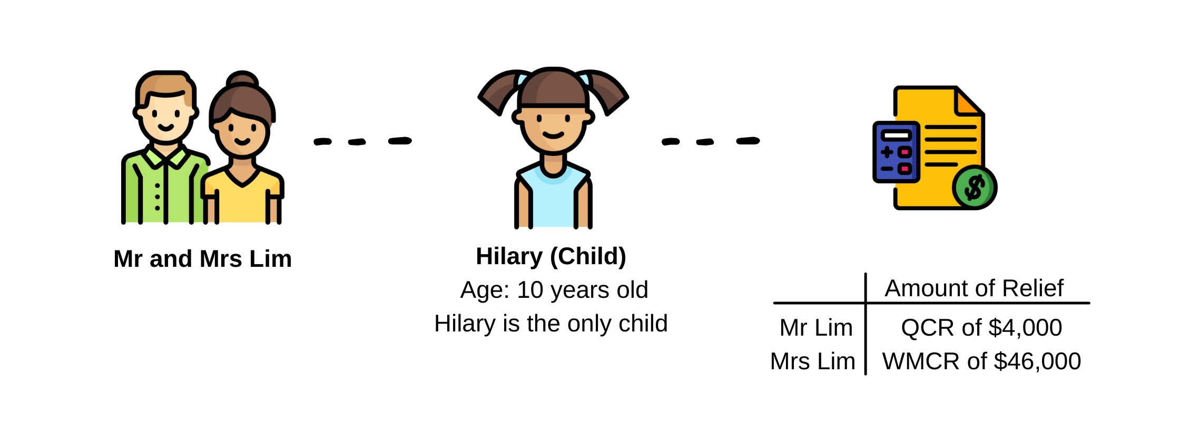

Example 5: Claiming QCR, Parenthood Tax Rebate (PTR) and WMCR for child born on or after 1 Jan 2024.

Mr and Mrs Chen's first child was born in 2025. Mrs Chen was working and had an earned income of $80,000 for that year.
They decided that Mrs Chen would claim the full amount of QCR of $4,000.
Mr and Mrs Chen are Singapore tax residents for YA 2026 and are entitled to PTR of $5,000 for their first child. They have agreed to share the amount of PTR equally (i.e. $2,500 each).
Mrs Chen's tax computation for YA 2026 is as follows:
Employment Income of Mrs Chen | $80,000
Less: Personal Reliefs
- Earned Income Relief | $1,000
- QCR | $4,000
- WMCR | $8,000
- CPF Relief | $16,000
Chargeable Income | $51,000 ($80,000 - $29,000)
Computation of Mrs Chen's tax payable for YA 2026
Chargeable Income for Mrs Chen | $51,000
First $40,000 | $550  (Based on the income tax rates for Singapore tax resident for YA 2026)
Next $11,000 @ 7% | $770
Tax Payable on Chargeable Income | $1,320
Less: Parenthood Tax Rebate | $1,320  [Mr and Mrs Chen are sharing the PTR of $5,000 for their first child born in 2025 (i.e. $2,500 per person). Any unutilised amount of PTR will be carried forward to offset against the income tax payable for subsequent years until the rebate has been fully utilised.]
Net Tax Payable | $0
How to claim
e-Filing
Is this the first time you are claiming the relief?
Yes  - Log in to myTax Portal your Singpass or Singpass Foreign user Account (SFA).  - Go to “Individuals” > “File Income Tax Return”.  - Select “File” to File Income Tax Return.  - Go to “4. Deductions, Tax Reliefs and Rebates”.  - Select “Add New” > “Child”.  - Fill in the relevant information and select “Update”. | No  If the relief has been allowed to you last year, the amount will be pre-filled and granted to you automatically this year.  Follow the steps on the left if you need to make any changes to your relief.

Paper filing
Is this the first time you are claiming the relief?
Yes  Form B1 & B  - Complete the item on “Child Relief”.  - Complete the particulars of your child in Appendix 2.  If you are also claiming Working Mother's Child Relief (WMCR), find out how to enter your WMCR claim. | No  Form B1 & B  Complete the item on “Child Relief”.  If you are also claiming WMCR, find out how to enter your WMCR claim.
First-time Child Relief (Disability) claims
Child Relief (Disability) may be allowed if:
S/N  1. | Eligibility  Your child requires assistance in any one of the 6 Activities of Daily Living (ADLs) for physical disability*:  *(1) Washing or Bathing, (2) Dressing, (3) Feeding, (4) Toileting, (5) Transferring and (6) Mobility | Details, Details  Making first-time claim  If you are claiming Child Relief (Disability) for the first time, please retain the relevant supporting documents indicating the disability details and commencement date, and submit them only when requested by IRAS, for example:  - Letter/ supporting documents from the disability association; or  - Medical report or doctor’s certification; or  - Completed Application for Claim of Disability Related Tax Reliefs (DOC, 413KB).
S/N  2. | Eligibility  Your child is impaired in any one of the 3 areas of activities for mental impairment^:  ^(1) Self Care and Activities of Daily Living, (2) Compliance to Psychiatric Treatment and (3) Education or Work
S/N  3. | Eligibility  Your child is attending or recommended by a doctor to attend a Special Education (SPED) school; or | Details  Please provide a copy of the medical report stating that your child is attending/recommended to attend a SPED school.
S/N  4. | Eligibility  Your child is not attending a SPED school but has significant special educational needs resulting in severe functional impairments. | Details  Please refer below for the details to provide.
If you no longer satisfy the conditions for Child Relief (Disability) (e.g. your child recovers from his/her condition), please withdraw the claim from your Income Tax Return if the relief has been auto-included for you as per your previous year’s assessment.
Expand all

*Physical disability – 6 ADLs
- Washing or bathing: Ability to bathe or shower (including getting into and out of the bath or shower) or wash by other means.
- Dressing: Ability to put on, take off, secure and unfasten all garments (upper and lower) and any braces, artificial limbs or other surgical appliances.
- Feeding: Ability to feed oneself after food has been prepared and made available.
- Toileting: Ability to use the toilet or manage bowel and bladder function through the use of protective undergarments or appropriate surgical appliances.
- Transferring: Ability to move from (a lying position on the) bed to an upright chair or wheelchair, and vice versa.
- Mobility: Ability to move indoors from room to room on level surfaces.

^Mental Impairment – 3 areas of activities

- Self Care and Activities of Daily Living: Ability to care for self and independently manage activities of daily living (i.e., washing/bathing, dressing, feeding, toileting, transferring and mobility).
- Compliance to psychiatric treatment: Ability to take medications and comply with prescribed psychiatric treatments.
- Education or work: Ability to integrate into the normal stream of education or to sustain gainful employment.
Child Relief (Disability) claim for child in Non-Special Education (SPED) school
If your child is not attending a SPED school but has significant special educational needs resulting in severe functional impairments, you may apply for the Child Relief (Disability). IRAS will review the application on a case-by-case basis.

Case-by-case basis review

I have filed my Income Tax Return but have yet to receive my tax bill for the current YA. What should I do if I have forgotten to claim, or need to amend my claim for QCR/Child Relief (Disability)?

1. If you e-Filed your Income Tax Return
You may re-file once by 18 Apr. When you re-file, you must include all your income details, expenses, donations and relief claims, where applicable. Once you have re-filed successfully, your new submission will override the previous submission.
2. If you filed a paper Income Tax Return or are unable to re-file online
Please file an amendment upon receiving your tax bill for the current YA. You may file the amendment via the 'Amend Tax Bill' digital service at myTax Portal within 30 days from the date of your Income Tax bill.
3. First-time Child Relief (Disability) claims
Please refer to the information provided under the topic on “First-time Child Relief (Disability) claims”.

I have received my tax bill for the current YA. What should I do if I need to amend my claim for QCR/Child Relief (Disability)?

Please file an amendment using the 'Amend Tax Bill' digital service at myTax Portal within 30 days from the date of your tax bill.
First-time Child Relief (Disability) claims
Please refer to the information provided under the topic on “First-time Child Relief (Disability) claims”.

I have received my tax bill for the current YA. It shows that I have been given QCR of $4,000. However, now I wish to let my husband claim the full QCR/share the QCR with him. What should I do?

You and your husband should file an amendment using the 'Amend Tax Bill' digital service at myTax Portal within 30 days from the date of your respective tax bills.

- Working Mother's Child Relief (if applicable)
Qualifying for relief
https://www.iras.gov.sg/taxes/individual-income-tax/basics-of-individual-income-tax/tax-reliefs-rebates-and-deductions/tax-reliefs/working-mother's-child-relief-(wmcr)

Single or male taxpayers are not eligible for WMCR.
Qualifying for relief
To claim WMCR for the Year of Assessment (YA) 2026, you must satisfy all these conditions in 2025:
- You are a working mother who is married, divorced or widowed;
- You have taxable earned income from employment or through pensions, trade or business, or through a profession or vocation. (Your taxable earned income is your total earned income less allowable expenses.);
- You have maintained a child who is a Singapore Citizen as at 31 Dec 2025* and has satisfied all conditions under the Qualifying Child Relief (QCR)/Child Relief (Disability).

*The amount of WMCR you can claim is based on the date your child became a Singapore Citizen.
- You may claim WMCR in your tax filing for YA 2026 even if your child has passed away in 2025.
- If your child was born or adopted before 1 Jan 2024 but became a Singapore Citizen only after 1 Jan 2024, the fixed dollar rate of WMCR will apply to you.
Determining child order
The amount of relief varies for each child based on the child order in the family unit. The order of your child is based on:
For a child born to you and your spouse/ex-spouse | Date of birth shown in your child's birth certificate
For a child born to you and your spouse/ex-spouse before you are married to your spouse/ex-spouse | Date of marriage
For a step-child | Date of birth shown in your child's birth certificate
For a legally adopted child | Date of legal adoption as shown in the adoption papers
A deceased/ stillborn child^ is counted in determining the order of children.
^Applicable from YA 2022 onwards for WMCR claims, where the married woman, divorcee or widow claiming the deduction is the natural mother of the stillborn child.
Amount of relief
The amount of WMCR that you may claim for each child is based on the child order. This is then matched to a fixed dollar tax relief.
The table below explains how the WMCR amount is calculated:
Child order | Qualifying Singaporean child born/adopted on or after 1 Jan 2024  Working Mother's Child Relief amount | Qualifying Singaporean child born/adopted before 1 Jan 2024  Working Mother's Child Relief amount
1st | $8,000 | 15% of mother's earned income
2nd | $10,000 | 20% of mother's earned income
3rd and beyond | $12,000 | 25% of mother's earned income

As part of the review of the Government’s support for Marriage and Parenthood, (PDF, 385KB) with effect from YA 2025, the WMCR will be changed from a percentage of an eligible working mother’s annual earned income to a fixed dollar tax relief for Singaporean children born or adopted on or after 1 Jan 2024.
If a mother claims WMCR for multiple children, the WMCR allowed for each child are added together and the total claim is capped at 100% of her earned income.
Please note that a personal income tax relief cap of $80,000 applies to the total amount of all tax reliefs claimed for each YA.
Collapse all

Example 1: Claiming WMCR on 2 children

Mrs Heng had an earned income of $100,000 in 2025. Her first child started working in 2025 and received an annual income exceeding $8,000. Mrs Heng’s second child was below 16 and studying full-time in 2025. The amount of WMCR that Mrs Heng may claim for YA 2026 is:
Child order1st | WMCR amount based on Mrs Heng's earned income of $100,000$15,000  (15% x $100,000) | WMCR allowable ($)Nil | Cumulative WMCR allowable ($)Nil  No WMCR is allowed on her first child as the child had income exceeding $8,000 in 2025
Child order2nd | WMCR amount based on Mrs Heng's earned income of $100,000$20,000  (20% x $100,000) | WMCR allowable ($)20,000 | Cumulative WMCR allowable ($)20,000  (20% of her earned income)

Example 2: Claiming WMCR on children born before and after 1 Jan 2024

Mrs Teo had an earned income of $90,000 in 2025. Her first child is 4 years old and her second child was born in 2024. The amount of WMCR that Mrs Teo may claim for YA 2026 is:
Child order1st | WMCR amount based on Mrs Teo's earned income of $90,000$13,500  (15% x $90,000) | WMCR allowable ($)13,500 | Cumulative WMCR allowable ($)13,500  (15% of her earned income)
Child order2nd | WMCR amount based on Mrs Teo's earned income of $90,000$10,000  (based on WMCR allowable for qualifying child born on or after 1 Jan 2024 with child order 2) | WMCR allowable ($)10,000 | Cumulative WMCR allowable ($)13,500 + 10,000 = 23,500
Claiming other reliefs on the same child
You may claim WMCR even if you and/or your husband or ex-husband has already claimed QCR/ Child Relief (Disability) on the same child. However, you must satisfy the following conditions:
- QCR/Child Relief (Disability) claims will be allowed first (it does not matter whether the claim is made by you or your husband/ex-husband);
- The total Child Relief cap (i.e. QCR/Child Relief (Disability) plus WMCR) is $50,000 per child; and
- The WMCR is limited to the remaining balance after the QCR/Child Relief (Disability) claim is allowed.

husband/ex-husband has claimed other child reliefs

Example 4: Claiming Parenthood Tax Rebate (PTR) and WMCR

Mr and Mrs Chen's first child was born in 2025. Mrs Chen was working and had an earned income of $80,000 for that year.
They decided that Mrs Chen would claim the full amount of QCR of $4,000.
Mr and Mrs Chen are Singapore tax residents for YA 2026 and are entitled to PTR of $5,000 for their first child. They have agreed to share the amount of PTR equally (i.e. $2,500 each).
Mrs Chen's tax computation for YA 2026 is as follows:
Employment Income of Mrs Chen | $80,000
Less: Personal Reliefs
- Earned Income Relief | $1,000
- QCR | $4,000
- WMCR | $8,000 (based on WMCR allowable for qualifying child born after 1 Jan 2024 with child order 1)
- CPF Relief | $16,000
Chargeable Income | $51,000 ($80,000 - $29,000)
Computation of Mrs Chen's tax payable for Year of Assessment 2026
Chargeable Income for Mrs Chen | $51,000
First $40,000 | $550  (Based on the income tax rates for Singapore tax resident for YA 2024 onwards)
Next $11,000 @ 7% | $770
Tax Payable on Chargeable Income | $1,320
Less: Parenthood Tax Rebate | $1,320  [Mr and Mrs Chen are sharing the PTR of $5,000 for their first child born in 2025 (i.e. $2,500 per person). Any unutilised amount of PTR will be carried forward to offset against the income tax payable for subsequent years until the rebate has been fully utilised.]
Net Tax Payable | $0
How to claim
e-Filing
Is this the first time you are claiming the relief?
Yes  - Log in to myTax Portal your Singpass or Singpass Foreign user Account (SFA).  - Go to “Individuals” > “File Income Tax Return”.  - Select “File” to File Income Tax Return.  - Go to “4. Deductions, Tax Reliefs and Rebates”.  - Select “Add New” > “Child”.  - Fill in the relevant information and select “Yes" under "Claim Working Mother's Child Relief.  - Select "Update". | No  If the relief has been allowed to you last year, the amount will be pre-filled and granted to you automatically this year.  Follow the steps on the left if you need to make any changes to your relief.

Paper filing
Is this the first time you are claiming the relief?
Yes  Form B1 & B  - Complete the item on “Child Relief”. Under the “Claim for WMCR” column, indicate Y.  - Complete the particulars of your child in Appendix 2. | No  Form B1 & B  Complete the item on “Child Relief”.
You need not enter the WMCR amount as we will automatically compute the allowable WMCR amount based on your eligibility, when we process your Income Tax Return.

How to claim
e-Filing
Is this the first time you are claiming the relief?
Yes  - Log in to myTax Portal your Singpass or Singpass Foreign user Account (SFA).  - Go to “Individuals” > “File Income Tax Return”.  - Select “File” to File Income Tax Return.  - Go to “4. Deductions, Tax Reliefs and Rebates”.  - Select “Add New” > “Child”.  - Fill in the relevant information and select “Yes" under "Claim Working Mother's Child Relief.  - Select "Update". | No  If the relief has been allowed to you last year, the amount will be pre-filled and granted to you automatically this year.  Follow the steps on the left if you need to make any changes to your relief.

Paper filing
Is this the first time you are claiming the relief?
Yes  Form B1 & B  - Complete the item on “Child Relief”. Under the “Claim for WMCR” column, indicate Y.  - Complete the particulars of your child in Appendix 2. | No  Form B1 & B  Complete the item on “Child Relief”.
You need not enter the WMCR amount as we will automatically compute the allowable WMCR amount based on your eligibility, when we process your Income Tax Return.
FAQs

I have filed my Income Tax Return but have yet to receive my tax bill for the current YA. What should I do if I have forgotten to claim, or need to amend my claim for WMCR?

1. If you e-Filed your Income Tax Return
You may re-file once by 18 Apr. When you re-file, you must include all your income details, expenses, donations and relief claims, where applicable. Once you have re-filed successfully, your new submission will override the previous submission.
2. If you filed a paper Income Tax Return or are unable to re-file online
Please file an amendment upon receiving your tax bill for the current YA. You may file the amendment via the 'Amend Tax Bill' digital service in myTax Portal within 30 days from the date of your Income Tax bill.

I have received my tax bill for the current YA. What should I do if I need to amend my claim for WMCR?

Please file an amendment using the 'Amend Tax Bill' digital service at myTax Portal within 30 days from the date of your tax bill.

How will WMCR be calculated if my child was born before 1 Jan 2024 but became a Singapore Citizen after 1 Jan 2024?

The WMCR amount is based on the date your child became a Singapore Citizen.
For example, if your first child was born on 30 Mar 2022 but became a Singapore Citizen on 4 May 2024, the WMCR amount for YA 2026, will be a fixed dollar tax relief of $8,000.
Frequently Asked Question
Q: I just had a newborn baby. What tax relief can I claim?
A: If you have a newborn child, you may be eligible for parenthood-related tax reliefs or rebates, subject to IRAS qualifying conditions. These may include:
- Qualifying Child Relief (QCR), if the child meets the qualifying conditions.
- Parenthood Tax Rebate (PTR), if the child is a Singapore Citizen and the parent meets the qualifying conditions.
- Working Mother’s Child Relief (WMCR), if the mother is working and meets the qualifying conditions.

- Earned Income Relief
Earn Income relief
https://www.iras.gov.sg/taxes/individual-income-tax/basics-of-individual-income-tax/tax-reliefs-rebates-and-deductions/tax-reliefs/earned-income-relief
You will receive Earned Income Relief if you have taxable earned income from any of the following sources in the previous year:
- Employment;
- Pension; or
- Trade, business, profession or vocation.
Amount of relief
The amount of Earned Income Relief is based on your age and taxable earned income (less any allowable expenses) in the previous year.
Your age as of 31 Dec of the previous year | Maximum amount claimable#
Below 55 | $1,000
55 to 59 | $6,000
60 and above | $8,000
#If the amount of taxable earned income is lower than the maximum amount claimable, the relief will be capped at the amount of taxable earned income.
For example, if you are 55 years old as at 31 Dec 2025 and have taxable earned income of $5,000 in 2025, you will get Earned Income Relief of $5,000 (instead of $6,000) for the Year of Assessment (YA) 2026.
Earned Income Relief for persons with disability
A higher Earned Income Relief (shown in the table below) will be given to those with permanent physical disability* or mental impairment^ that severely affects their ability to work.
Your age as of 31 Dec of the previous year | Maximum amount claimable#
Below 55 | $4,000
55 to 59 | $10,000
60 and above | $12,000
#If the amount of taxable earned income is lower than the maximum amount claimable, the relief will be restricted to the amount of taxable earned income.
Collapse all

*Physical disability – 6 Activities of Daily Living (ADLs)

You require assistance in any one of the 6 ADLs:
- Washing or bathing: Ability to bathe or shower (including getting into and out of the bath or shower) or wash by other means.
- Dressing: Ability to put on, take off, secure and unfasten all garments (upper and lower) and any braces, artificial limbs or other surgical appliances.
- Feeding: Ability to feed oneself after food has been prepared and made available.
- Toileting: Ability to use the toilet or manage bowel and bladder function through the use of protective undergarments or appropriate surgical appliances.
- Transferring: Ability to move from (a lying position on the) bed to an upright chair or wheelchair, and vice versa.
- Mobility: Ability to move indoors from room to room on level surfaces.

^Mental Impairment – 3 areas of activities

You are impaired in any one of the 3 areas of activities:
- Self Care and Activities of Daily Living: Ability to care for self and independently manage activities of daily living (i.e., washing/bathing, dressing, feeding, toileting, transferring and mobility).
- Compliance to psychiatric treatment: Ability to take medications and comply with prescribed psychiatric treatments.
- Education or work: Ability to integrate into the normal stream of education or to sustain gainful employment.
How to claim
You do not need to claim Earned Income Relief in your Income Tax Return as it will be automatically granted to you based on your eligibility.
First-time claim for Earned Income Relief (Disability)
If you are claiming Earned Income Relief (Disability) for the first time, please retain the relevant supporting documents indicating the disability details and commencement date, and submit them only when requested by IRAS, e.g.:
- Letter/supporting documents from the disability association; or
- Medical report or doctor’s certification; or
- Completed Application for Claim of Disability - Related Tax Reliefs (DOC, 413KB).
You also need to complete your Income Tax Return as follows:
- If you are e-Filing your Income Tax Return: Enter the details of your disability under Section “4. Deductions, Tax Reliefs and Rebates” > “Earned Income Relief”.
- If you are submitting a paper Income Tax Return: Enter the details of your disability in Appendix 2 of the Income Tax Return.
We will automatically grant you Earned Income Relief (Disability) in subsequent years if you are eligible. You do not need to enter the claim in your Income Tax Return in subsequent years.
FAQs

I have filed my Income Tax Return but have yet to receive my tax bill for the current YA. This is my first time claiming Earned Income Relief (Disability). What should I do if I have forgotten to claim the relief?

1. If you e-Filed your Income Tax Return
You may re-file once by 18 Apr. When you must include all your income details, expenses, donations and relief claims, where applicable. Once you have re-filed successfully, your new submission will override the previous submission.
2. If you filed a paper Income Tax Return or are unable to re-file online
Please file an amendment upon receiving your tax bill for the current YA. You may file the amendment via the 'Amend Tax Bill' digital service at myTax Portal within 30 days from the date of your Income Tax bill.

- NSman Relief
https://www.iras.gov.sg/taxes/individual-income-tax/basics-of-individual-income-tax/tax-reliefs-rebates-and-deductions/tax-reliefs/central-provident-fund(cpf)-relief-for-employees

NSman Relief (Self, Wife and Parent)
https://www.iras.gov.sg/taxes/individual-income-tax/basics-of-individual-income-tax/tax-reliefs-rebates-and-deductions/tax-reliefs/nsman-relief-(self-wife-and-parent)
Share:
All eligible operationally ready National Servicemen (NSmen) are entitled to NSman tax relief. NSman Relief is to recognise their contributions to National Service. This relief is allowed based on national service done in the previous work year (i.e. from 1 Apr to 31 Mar).
NSman Wife and NSman Parent Reliefs are also given to the wives and parents of NSmen respectively to recognise the support they give to their husbands and sons.
Examples of NSman Relief claims
NSman Self Relief

Qualifying for NSman Self Relief

To qualify for this relief:
- You must have completed your full-time National Service under the Enlistment Act (Cap. 93); or
- You are deemed to have completed such service by the proper authority.
Regulars from MINDEF, the Singapore Police Force or the Singapore Civil Defence Force, the Central Narcotics Bureau*, the Singapore Prison Service* and NSmen who have committed any disciplinary or criminal offences in the preceding work year are excluded.
*with effect from the Year of Assessment 2021 onwards.

Amount of NSman Self Relief

The amount of relief depends on whether:
- You performed NS activities in the preceding work year^; and
- You are a NS key command and staff appointment holder.
^For the Year of Assessment 2026, the relevant work year is from 1 Apr 2025 to 31 Mar 2026.
Ex-NSmen or NS-liable ex-regular servicemen above the statutory age are given the base quantum of $1,500.
Did you perform NS activities in the preceding year?  No | NSmen  (General population)  $1,500 | NS key command and staff appointment holders  $3,500
Did you perform NS activities in the preceding year?  Yes | NSmen  (General population)  $3,000 | NS key command and staff appointment holders  $5,000

How to claim NSman Self Relief

You do not need to claim NSman Self Relief as IRAS will automatically grant this relief to you based on your eligibility and records sent to us by MINDEF, SPF and SCDF.
If you have performed NS activities between 1 Jan to 31 Mar of the current year, the amount of NSman Relief reflected at the time of your e-Filing or in your tax bill might not have been updated, as the information would only be transmitted to IRAS by the relevant authorities after the end of the work year (i.e. work year is from 1 Apr to 31 Mar). A revised tax bill would be issued to you if there are any subsequent adjustments sent in by the relevant authorities.
If you and your son are both NSmen, you will be eligible for either the NSman Self Relief or NSman Parent Relief, whichever is the higher.
NSman Wife Relief
Collapse all

Qualifying for NSman Wife Relief

To qualify for this relief:
- You are a Singapore Citizen in the preceding year; and
- Your husband is eligible for NSman Self Relief.
Widows of deceased NSmen may also be eligible for the relief unless they have re-married.

Amount of NSman Wife Relief

The amount of relief is $750.

How to claim NSman Wife Relief

You do not need to claim this relief as IRAS will automatically grant it to you based on your eligibility.
If you are eligible but the relief is not shown in your annual tax filing or tax bill, you may email us via the 'myTax Mail' digital service at myTax Portal with the following details:
- the Year of Assessment that you wish to claim the relief;
- a copy of your marriage certificate; and
- your confirmation that you have met the qualifying conditions.
When there is a change in your marital status (e.g. divorce) and the relief is incorrectly shown during your annual tax filing or in your tax bill, you may email us via the 'myTax Mail' digital service at myTax Portal with the following details:
- the Year of Assessment for which you wish to withdraw the relief; and
- a copy of your divorce certificate.
NSman Parent Relief

Qualifying for NSman Parent Relief
To qualify for this relief:
- You are a Singapore Citizen in the preceding year;
- Your child is eligible for NSman Self Relief; and
- Your child was born to you and your spouse/ex-spouse or your step-child or legally adopted child.
Parents of deceased NSmen are also eligible for this relief. If you and your son are both NSmen, you will be eligible for either the NSman Self Relief or the NSman Parent Relief, whichever is higher.

Amount of NSman Parent Relief
The amount of relief for each parent is $750 regardless of the number of children who are NSmen.

How to claim NSman Parent Relief
You do not need to claim this relief as IRAS will automatically grant it to you based on your eligibility.
If you are eligible but the relief is not shown in your annual tax filing or tax bill, you may email us via the 'myTax Mail' digital service at myTax Portal with the following details:
- the Year of Assessment for which you wish to claim the relief;
- a copy of your son's birth certificate; and
- your confirmation that you have met the qualifying conditions.
Examples of NSman Relief claims

Example 1: Parents with 1 son who is an NSman

The maximum NSman Parent Relief for each parent is $750.
Relief for  Father (not eligible for NSman Self Relief) | Type of relief  NSman Parent Relief | Amount of relief  $750
Relief for  Mother | Type of relief  NSman Parent Relief | Amount of relief  $750

Example 2: Parents with 3 sons who are all NSmen

The maximum NSman Parent Relief for each parent is $750.
Relief for  Father (not eligible for NSman Self Relief) | Type of relief  NSman Parent Relief | Amount of relief  $750
Relief for  Mother | Type of relief  NSman Parent Relief | Amount of relief  $750

Example 3: A father and his son are NSmen

Both father and son belong to the general population of NSmen and did not perform any NS activity in the preceding work year. The amount of relief for the father is $1,500 (the higher amount).
Relief for, Relief for  Father | Type of relief  NSman Parent Relief | Amount of relief  $750 (not allowed)
 | Type of relief  NSman Self Relief | Amount of relief  $1,500 (allowed)

Example 4: A mother has a son and husband who are both NSmen

The amount of relief for the mother is $750.
Relief forMother | Type of relief  She is entitled to either:  - NSman Parent Relief; or  - NSman Wife Relief | Amount of relief$750

- CPF Relief
Central Provident Fund (CPF) Relief for employees
Share:
CPF Relief is given to encourage individuals to save for their retirement. Employees who are Singapore Citizens or Singapore Permanent Residents may claim CPF Relief.

Contributions that qualify for relief
- Compulsory employee CPF contributions under the CPF Act or contributions to an approved pension or provident fund;
- Voluntary Contributions to your MediSave Account.

Please note that a personal income tax relief cap of $80,000 applies to the total amount of all tax reliefs claimed (including relief on compulsory/voluntary CPF contributions) for each Year of Assessment (YA).
There will be no refund for accepted voluntary CPF contributions. Please evaluate whether you would benefit from tax relief on your voluntary CPF contributions and make an informed decision.
Contributions not eligible for relief
- Voluntary contributions made in excess of the compulsory contributions under the CPF Act
- CPF contributions on additional wages that exceed the CPF cap on wages from related employers (employed concurrently by 2 or more related employers in a year)
- CPF contributions made in respect of your overseas employment (i.e. while you are seconded or posted overseas for work).
Amount of relief
CPF Relief is capped by the amount of compulsory employee CPF contributions made on Ordinary Wages and Additional Wages under the CPF Act.
The amount of CPF Relief is capped to ensure that CPF is not used as a tax shelter.

Ordinary Wages and Additional Wages

You may claim CPF Relief for making employee CPF contributions on wages that have not exceeded the Ordinary Wage ceiling and Additional Wage ceiling.
As announced in Budget 2023, the CPF monthly salary ceiling will be increased to $8,000 in four phases starting from 1 Sep 2023.
Ordinary Wage (OW) ceiling
Period1 Jan to 31 Aug 2023 | CPF monthly salary ceiling$6,000
Period1 Sep to 31 Dec 2023 | CPF monthly salary ceiling$6,300
Period1 Jan to 31 Dec 2024 | CPF monthly salary ceiling$6,800
Period1 Jan to 31 Dec 2025 | CPF monthly salary ceiling$7,400
PeriodOn or after 1 Jan 2026 | CPF monthly salary ceiling$8,000
Notwithstanding the increases to the CPF monthly salary ceiling starting from 1 Sep 2023, the CPF annual salary ceiling will remain at $102,000.
Additional Wage (AW) ceiling
1 Jan to 31 Dec 2025 | $102,000 less Total OW subject to CPF  ($102,000 = 17 months x $6,000)
The additional wage ceiling will remain at $102,000 less total ordinary wages subject to CPF for the relevant year.
For more information on OW ceiling and AW ceiling, please refer to CPF Board's website.
Examples on computations of CPF Relief
Collapse all

Example 1: Additional Wages exceed the ceiling

Mr Lim is 40 years old. His compulsory employee CPF contribution rate is 20%. He received the following income in 2025:
Employment period: 1 Jan to 31 Dec 2025  Total wages for 2025 | Ordinary Wage (OW)  $5,500 x 12 months = $66,000 | Additional Wage (AW)  $40,000
Employment period: 1 Jan to 31 Dec 2025  OW & AW ceiling | Ordinary Wage (OW)  $7,400 x 12 months = $88,800 | Additional Wage (AW)  $102,000 – (A)  = $102,000 - $66,000  = $36,000
Employment period: 1 Jan to 31 Dec 2025  Wages subject to compulsory CPF contributions | Ordinary Wage (OW)  $66,000 (A)  The OW ($66,000) is subject to compulsory CPF contributions as the total OW for the year has not exceeded the OW ceiling ($88,800). | Additional Wage (AW)  $36,000  The AW ($40,000) exceeds the AW ceiling ($36,000). The AW subject to compulsory CPF contribution is capped at $36,000.
Mr Lim's CPF Relief for the YA 2026 is computed as follows:
CPF Relief on  OW | Amount  $66,000 x 20% = $13,200
CPF Relief on  AW | Amount  $36,000 x 20% = $7,200
CPF Relief on  Total CPF Relief allowed for YA 2026 | Amount  = $20,400 ($13,200 + $7,200)

Example 2: Ordinary Wages exceed the ceiling

Mr Heng is 35 years old. His compulsory employee CPF contribution rate is 20%. He received the following income in 2025:
Employment period: 1 Jan to 31 Dec 2025  Total wages for 2025 | Ordinary Wage(OW)  $7,600 x 12 months = $91,200 | Additional Wage (AW)  $13,000
Employment period: 1 Jan to 31 Dec 2025  OW & AW ceiling | Ordinary Wage(OW)  ($7,400 x 12 months)  = $88,800 | Additional Wage (AW)  $102,000 – (A)  = $102,000 - $88,800  = $13,200
Employment period: 1 Jan to 31 Dec 2025  Wages subject to compulsory CPF contributions | Ordinary Wage(OW)  $88,800 (A)  The OW ($91,200) has exceeded the OW ceiling ($88,800). OW subject to compulsory CPF contribution is capped at $88,800. | Additional Wage (AW)  $13,000  The AW ($13,000) is subject to compulsory CPF contributions as the AW has not exceeded the AW ceiling ($13,200).
Mr Heng's CPF Relief for YA 2026 is computed as follows:
CPF Relief on  OW | Amount  $88,800 x 20% = $17,760
CPF Relief on  AW | Amount  $13,000 x 20% = $2,600
CPF Relief on  Total CPF Relief allowed for YA 2026 | Amount  = $20,360 ($17,760 + $2,600)

Example 3: Total wages exceed the ceiling

Ms Cheong is 29 years old. Her compulsory employee CPF contribution rate is 20%. Her last date of employment was 30 Nov 2025. She received the following income in 2025:
Employment period:  1 Jan to 30 Nov 2025  Total wages for 2025 | Ordinary Wage (OW)  $7,500 x 11 months = $82,500 | Additional Wage (AW)  $45,000
Employment period:  1 Jan to 30 Nov 2025  OW & AW ceiling | Ordinary Wage (OW)  Jan to Nov 2025  = $7,400 x 11 months  = $81,400 | Additional Wage (AW)  $102,000 - (A)  = $102,000 - $81,400  = $20,600
Employment period:  1 Jan to 30 Nov 2025  Wages subject to compulsory CPF contributions | Ordinary Wage (OW)  $81,400 (A)  The OW ($82,500) has exceeded the OW ceiling ($81,400). The OW subject to compulsory CPF contribution is capped at $81,400. | Additional Wage (AW)  $20,600  The AW ($45,000) has exceeded the AW ceiling ($20,600). The AW subject to compulsory CPF contribution is capped at $20,600.
Ms Cheong's CPF Relief for YA 2026 is computed as follows:
CPF Relief on  OW | Amount  $81,400 x 20% = $16,280
CPF Relief on  AW | Amount  $20,600 x 20% = $4,120
CPF Relief onTotal CPF Relief allowed for YA 2026 | Amount  = $20,400 ($16,280 + $4,120)

Example 4: Employee makes voluntary contribution to MediSave Account* (Up to YA 2022)

Andrew is 30 years old. He made voluntary contributions to his MediSave Account in 2021. His CPF Relief for the YA 2022 is computed as follows:
Andrew is an employee who is 30 years old | YA 2022
Total wages (OW + AW) | $80,000
Compulsory CPF contributions made by Andrew's employer | 17% x $80,000  = $13,600
Compulsory CPF contributions by Andrew as an employee | 20% x $80,000  = $16,000
Total CPF contributions by Andrew and his employer | $13,600 + $16,000 = $29,600
Annual CPF contribution cap | $37,740*
Voluntary cash contribution directed by Andrew to his MediSave Account | $9,000
Maximum tax relief allowed on voluntary contribution made by Andrew to his MediSave Account | $8,140  ($37,740 - $29,600)
Total CPF Relief allowable to Andrew | $24,140  ($16,000 + $8,140)
*The above tax treatment ceased for voluntary contributions made from 1 Jan 2022 to an individual’s own MediSave Account (“MA”). From 1 Jan 2022, the contributions limit for voluntary contributions made by individuals to their MA will only be subject to the Basic Healthcare Sum and not the annual CPF contribution cap. The voluntary contributions made to the MA will be allowed under CPF Cash Top-up Relief.

How to claim
e-Filing
Is your employer participating in the Auto-Inclusion Scheme?
No  - Log in to myTax Portal with your Singpass or Singpass Foreign user Account (SFA).  - Go to “Individuals” > “File Income Tax Return”.  - Select “File” to File Income Tax Return.  - Go to “1. Employment Income and Expense”.  - Tick check box “My employer (s) will not be transmitting my income details to IRAS”  - Select “Add New” > “Employment Income” > Input relevant details for “Employer (s) Not Under Auto Inclusion Scheme”  - Fill in the relevant information and select “Update”. | Yes  If your employer is one of the participants of the Auto-Inclusion Scheme for Employment Income, you do not need to claim this relief.  We will automatically grant you this relief based on the information sent to us by your employer.

Paper filing
Is your employer participating in the Auto-Inclusion Scheme?
No  Form B1 & B  Complete the item on “CPF Relief”. | Yes  Form B1 & B  If your employer is one of the participants of the Auto-Inclusion Scheme for Employment Income, you do not need to claim this relief.  We will automatically grant you this relief based on the information sent to us by your employer.

I have filed my Income Tax Return but have yet to receive my tax bill for the current YA. What should I do if I have forgotten to claim the CPF Relief?

1. If your employer is not participating in the Auto-Inclusion Scheme for Employment Income
If you e-Filed your Income Tax Return, you may re-file once by 18 Apr. When you re-file, you must include all your income details, expenses, donations and relief claims, where applicable. Once you have re-filed successfully, your new submission will override the previous submission.
If you filed a paper Income Tax Return or are unable to re-file online, please file an amendment upon receiving your tax bill for the current YA. You may file the amendment via the 'Amend Tax Bill' digital service at myTax Portal within 30 days from the date of your Income Tax Bill.
2. If your employer is participating in the Auto-Inclusion Scheme for Employment Income
You should verify that the auto-included information is correct. If the CPF relief shown is incorrect, please seek clarification with your employer directly and inform them to re-transmit the correct information to us.
Otherwise, IRAS will automatically grant you this relief based on the information sent to us by your employer.

I have received my tax bill for the current YA. I realise that I had submitted the amount of CPF Relief incorrectly. What should I do?

Please file an amendment using the 'Amend Tax Bill' digital service at myTaxPortal within 30 days from the date of your tax bill.

Can I obtain a refund of the voluntary CPF contributions I made in the previous year, if for the current Year of Assessment, the total amount of personal reliefs that I can claim is more than $80,000, even without any tax relief on voluntary CPF contributions I made?

There will be no refund for accepted voluntary CPF contributions. Before making voluntary CPF contributions, you should note that the overall personal income tax relief cap of $80,000 applies and evaluate whether you would benefit from tax relief on your voluntary CPF contributions.

- Course Fees Relief
https://www.iras.gov.sg/taxes/individual-income-tax/basics-of-individual-income-tax/tax-reliefs-rebates-and-deductions/tax-reliefs/course-fees-relief
- Course Fees Relief has been discontinued with effect from Year of Assessment (YA) 2026. The final year in which Course Fees Relief may be claimed is in YA 2025.
- Course Fees Relief is given to encourage individuals to continuously upgrade their skills and enhance employability.

Scenarios for deferring Course Fees Relief claims

Courses that qualify for relief
You may claim Course Fees Relief for the YA 2025 if you have attended:
- Any course of study, seminar or conference in 2024 for the purpose of gaining an approved academic, professional or vocational* qualification

* Approved vocational qualification

- Any course, seminar or conference in 2024 that is relevant to your current employment, trade, business, profession or vocation
- Any course, seminar or conference between 1 Jan 2022 to 31 Dec 2023 that is relevant to your new employment, trade, business, profession or vocation in 2024
Courses not eligible for relief
- Courses, seminars and conferences for recreation, leisure or hobby (e.g. photography, language and sports courses)
- Courses, seminars and conferences for general knowledge or skills (e.g. courses on Internet surfing, social media skills, basic website building, Microsoft Office)
- Polytechnic/University courses if graduates have never exercised any employment or carried on any trade, profession or vocation previously. Vacation jobs or internships are not considered employment for the purpose of this relief.
Amount of relief
You may claim the actual course fees incurred by yourself, up to a maximum of $5,500 each year regardless of the number of courses, seminars or conferences you have attended.
Any amount paid or reimbursed by your employer or any other organisations (including the use of SkillsFuture Credit) cannot be claimed as Course Fees Relief.
You may claim the following types of fees:
- Aptitude test fees (for computer courses);
- Examination fees;
- Registration/enrolment fees;
- Tuition fees.

Example 1: Course fees partially paid by employer

You are working as a photographer and have attended a photo-editing workshop that cost $1,500. Your employer subsidised 75% of the cost of your workshop.
The amount of Course Fees Relief you may claim is:
25% x $1,500 = $375
Courses that span a few years
For courses that span a few years and where full payment has been made upfront, you may divide the course fees paid equally over the years.

Example 2: 3-year course where full payment has been made upfront

You paid $15,000 for a 3-year course starting in 2022 till 2024.
The amount of relief you may claim for each YA (2023 to 2025) is:
$15,000 / 3 = $5,000
Deferring Course Fees Relief claims
If your assessable income does not exceed $22,000 throughout the duration of the course, seminar or conference, you may defer and claim the Course Fees Relief:
- in the first YA when your assessable income exceeds $22,000; or
- within 2-YA period from the YA relating to the year you have completed the course or attended the seminar or conference, whichever is earlier.
Scenarios for deferring Course Fees Relief claims
Collapse all

Scenario 1: Assessable income ≤ $22,000 throughout the course duration

Ms Lim is a hairdresser who took up a part-time vocational course in tourism. Her course began on 1 July 2020 and ended on 30 May 2022.
She continues working as a hairdresser after she completed the course. Her annual assessable income, course fee expenditure and amount of Course Fees Relief are as follows:
Year  2020 | Year of Assessment (YA)  2021 | Annual Assessable Income  $19,000 | Course Fees Paid  $2,000 | Course Fees Relief  Deferred
Year  2021 | Year of Assessment (YA)  2022 | Annual Assessable Income  $20,000 | Course Fees Paid  $3,000 | Course Fees Relief  Deferred
Year  2022 | Year of Assessment (YA)  2023 | Annual Assessable Income  $21,000 | Course Fees Paid  $1,000 | Course Fees Relief  Deferred
Year  2023 | Year of Assessment (YA)  2024 | Annual Assessable Income  $21,500 | Course Fees Paid  Nil | Course Fees Relief  Deferred
Year  2024 | Year of Assessment (YA)  2025 | Annual Assessable Income  $23,000 | Course Fees Paid  Nil | Course Fees Relief  $5,500
Ms Lim may defer her claim on Course Fees Relief until YA 2024 or YA 2025, since her assessable income for YA 2021 to YA 2023 (i.e. during the course duration) did not exceed $22,000.
As Ms Lim’s assessable income did not exceed $22,000 in YA 2024, she may claim the relief of up to $5,500^ in YA 2025.
^When a taxpayer defers a claim in Course Fees Relief, it can only be claimed once, with a maximum allowable relief of $5,500.

Scenario 2: Assessable income fluctuates above and below $22,000

Mr Goh is an IT security executive. In 2021, he resigned from his company and took a 2-year Master's degree course in IT Security Management.
After completing his first year, he deferred his course for a year and in 2022, worked full time. He resumed his full-time course in 2023.
On completing his course in 2024, he was again employed by his former employer. His annual assessable income, course fee expenditure and amount of Course Fees Relief are as follows:
Year  2021 | Year of Assessment (YA)  2022 | Annual Assessable Income  $15,000 | Course Fees Paid  $4,000 | Course Fees Relief  Deferred
Year  2022 | Year of Assessment (YA)  2023 | Annual Assessable Income  $40,000 | Course Fees Paid  Nil | Course Fees Relief  $4,000
Year  2023 | Year of Assessment (YA)  2024 | Annual Assessable Income  Nil | Course Fees Paid  $3,000 | Course Fees Relief  Deferred
Year  2024 | Year of Assessment (YA)  2025 | Annual Assessable Income  $50,000 | Course Fees Paid  Nil | Course Fees Relief  $3,000
In YA 2023, Mr Goh must claim the relief for course fees of $4,000 incurred in 2021 as his assessable income has exceeded $22,000 in YA 2023.
Similarly, in YA 2025, he must claim the relief on course fees of $3,000 incurred in 2023 as his annual income has exceeded $22,000 in YA 2025.

Scenario 3: Deferred claim is forfeited
Mrs Lau was a finance executive. She attended a 3-year part-time accountancy post-diploma course from 2020 to 2022. On completion, she became a homemaker.
Her annual assessable income, course fee expenditure and amount of Course Fees Relief are as follows:
Year  2020 | Year of Assessment (YA)  2021 | Annual Assessable Income  $20,000 | Course Fees Paid  $2,500 | Course Fees Relief  Deferred
Year  2021 | Year of Assessment (YA)  2022 | Annual Assessable Income  $25,000 | Course Fees Paid  $4,000 | Course Fees Relief  $5,500
Year  2022 | Year of Assessment (YA)  2023 | Annual Assessable Income  Nil | Course Fees Paid  $1,000 | Course Fees Relief  Deferred
Year  2023 | Year of Assessment (YA)  2024 | Annual Assessable Income  Nil | Course Fees Paid  Nil | Course Fees Relief  Deferred
Year  2024 | Year of Assessment (YA)  2025 | Annual Assessable Income  Nil | Course Fees Paid  Nil | Course Fees Relief  Forfeited
In YA 2022, Mrs Lau must claim the relief for course fees incurred in 2020 and 2021 (total = $6,500) as her income exceeded $22,000 in YA 2022. The relief has been capped at $5,500.
As Mrs Lau has no assessable income during YA 2024 and YA 2025, she will not be able to claim the relief on the course fees ($1,000) incurred in 2022. This amount is forfeited in YA 2025.

Scenario 4: Claim in YA 2025 for course taken in 2022

Ms Tan is an engineer. She quit her job and took up a baking course in Mar 2022. She completed the course in Aug 2022. In Sep 2024, she opened a bakery.
Her annual assessable income, course fee expenditure and amount of Course Fees Relief are as follows:
Year2022 | Year of Assessment (YA)2023 | Annual Assessable Income$80,000 | Course Fees Paid$3,000 | Course Fees ReliefNil. The course is not related to her profession as an engineer in 2022.
Year2023 | Year of Assessment (YA)2024 | Annual Assessable IncomeNil | Course Fees PaidNil | Course Fees ReliefNil

- Foreign Domestic Worker Levy Relief
Foreign Domestic Worker Levy (FDWL) Relief
Share:

The FDWL Relief has been discontinued with effect from Year of Assessment (YA) 2025. The final year in which FDWL Relief may be claimed is in YA 2024.
FDWL Relief is given to encourage married women to stay in the workforce. Singles and married men are not eligible for the FDWL Relief.
https://www.iras.gov.sg/taxes/individual-income-tax/basics-of-individual-income-tax/understanding-my-income-tax-filing/tax-season-2026---all-you-need-to-know
- Relief Claim Procedures
Tax Season 2026 - All you need to know
Share:
You may start filing your Income Tax between 1 Mar and 18 Apr 2026. This page outlines the steps and information required when filing.
Need help with e-filing? Visit go.gov.sg/efilingguide to view our step-by-step e-Filing guides.
On this page:FAQs
Understanding what happens during tax season
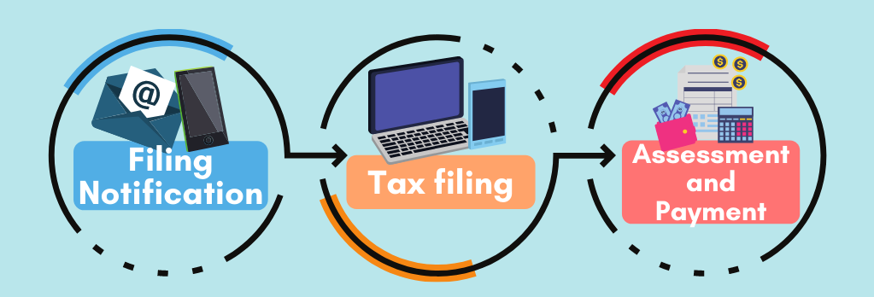
Filing notifications (SMS/Email/Letter) are sent between Feb and Mar. | If you received a notification to file, you may file from 1 Mar to 18 Apr. | Tax bills are issued progressively. To find out when you will receive yours, refer to Tax Season 2026 – About Your Tax bill.
If you have updated your notification preferences to receive digital notices, you will be notified via SMS and/or email when your Notice of Assessment is ready for viewing at myTax Portal.

To update your notice preferences, you may use the 'Update Contact & Notice Preferences' digital service at myTax Portal.
Find out your tax filing obligation from 1 Mar
To find out if you are required to file an Income Tax Return, log into myTax Portal:
MYTAX PORTAL
If your myTax Portal displays:

You are not required to file your tax return. – We will notify you once your tax bill is ready or if any action is required from you.

- You are under Direct Notice of Assessment (D-NOA).
- No action is required from you at the moment.
- IRAS will inform you if any action is required.
- Otherwise, your Notice of Assessment (NOA) (i.e. tax bill) will be finalised based on your income information submitted by your employer, eligible tax reliefs based on your previous assessment year's approved claims, and other relevant information available in our records.
- You will receive your NOA from mid Mar.
- If there is any inaccurate information (i.e. income and/or relief claims) in your NOA, please use the 'Amend Tax Bill' digital service to make the necessary adjustments within 30 days from the date of your tax bill.

You are not required to file your tax return. Verify by 18 Apr 2026 – You are under the No-Filing Service. View your tax return and check that the pre-filled income and relief information are correct by 18 Apr 2026.

- You do not need to file an Income Tax Return. You may verify your pre-filled information by clicking the "Verify" button displayed in myTax Portal.
- If you wish to make any adjustments, you may file your Income Tax Return (click on “Individuals” > “File Income Tax Return”) by 18 Apr 2026 to update your income and relief details, such as:
  - Additional or non-pre-filled sources of income to report (e.g. rental income); or
  - Changes to your personal relief claims (e.g. you no longer meet the qualifying conditions).

You are required to file your tax return. – Due by 18 Apr 2026

- File your Income Tax Return by clicking the "File" button displayed in myTax Portal by 18 Apr 2026.
- If your employer is in the Auto-Inclusion Scheme (AIS) for employment income:
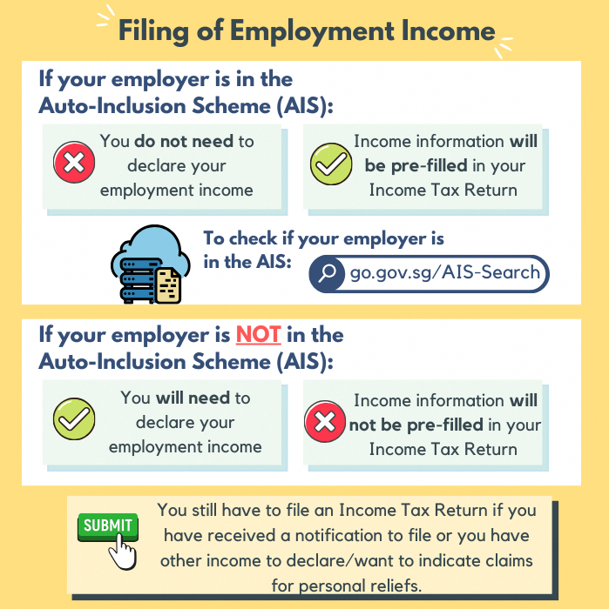
- They will submit your income information to IRAS by 1 Mar each year.
- You do not need to declare your employment income information as this will be pre-filled in your Income Tax Return.
- If the details are not shown under the “Employment Income and Expenses” section in the Income Tax Return, tick the “My employer(s) will transmit my income details to IRAS; I do not need to report them myself.” option:
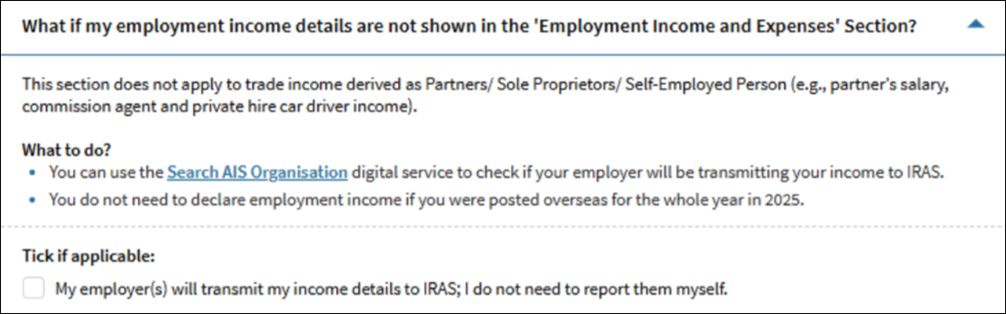

No messages or actions required displayed

- Generally, you will be required to submit your Income Tax Return if in the preceding calendar year (i.e. from 1 Jan to 31 Dec 2025):
  - Your total income is more than $22,000; or
  - You have self-employment income with a net profit more than $6,000; or
  - You are a non-resident who derived income from Singapore
- If you meet any of the requirements above, please proceed to file your Income Tax Return (click on “Individuals” > “File Income Tax Return”). Otherwise, you do not need to file an Income Tax Return.
What happens after you file
You will see an acknowledgment page on the screen after you click “Submit” if you have successfully filed.
If there are any changes, you may re-file your Income Tax Return once by 18 Apr.
You will generally receive your Notice of Assessment (i.e. tax bill) from end Apr to end Sep 2026*.
Check your tax bill to ensure that it is accurate. You have a legal duty to inform IRAS of any inaccurate information on your income and/or relief claims in your tax bill. There are penalties for failing to do so.
Refer to Tax Season 2026 - About your tax bill for more information.
*If you are under the Direct Notice of Assessment (D-NOA) scheme, you would have received your tax bill in Mar 2026.

1. My pre-filled employment income is wrong, what should I do?

Your employer has submitted your income information for the year 2025 (Year of Assessment 2026) to us directly. For any discrepancy, please check with your employer directly. They will resubmit the information to us if there are errors in the original submission, and this will be included in your tax bill.

2. My employer is not under Auto-Inclusion Scheme (AIS), what information do I need to file my Income Tax Return?

If your employer is not participating under AIS, your employer should have provided you with the Form IR8A by 1 Mar. You should enter the details during your tax filing as per the information in your Form IR8A. If you do not have the Form IR8A, please request it from your employer.
You are not required to submit your Form IR8A or other supporting documents unless specifically stated at the acknowledgement page after you have filed.

3. Can I claim personal reliefs and rebates?

You may claim personal reliefs and rebates if you are Singapore tax resident and have met the qualifying conditions for the respective reliefs/rebates in the preceding year (i.e. 1 Jan to 31 Dec 2025).
Find out which reliefs you may be eligible for:
PERSONAL RELIEF CHECKER
To check your eligibility for Parenthood Tax Rebate, use the Parenthood Tax Rebate Eligibility Tool (XLSM, 67KB).

4. Can I claim expenses?

Generally, you may claim tax deductions on expenses "wholly and exclusively" incurred in earning your income. Find out more about deductions for the different types of expenses (e.g. employment expenses, business expenses).
To simplify the tax filing for rental expenses, you may opt to claim the rental expenses based on 15% of the gross rental income derived from the tenanted residential property, instead of the actual amount of deductible expenses incurred. In addition to the 15%, you may claim a deduction on interest paid on the loan taken to purchase the property. You may use the Rental Calculator (XSLM, 146KB) to decide if it is beneficial to claim 15% deemed rental expenses or to claim based on actual rental expenses incurred. Find out more about the Simplification of Claim of Rental Expenses for Individuals.

5. What if I require more time to file my Income Tax Return?

If you need additional time to file your Income Tax Return, an extension of up to 14 days may be granted. You may use 'Apply for Extension of Time to File' digital service at myTax Portal.

- Relief Cap
Personal Income Tax Relief Cap
https://www.iras.gov.sg/taxes/individual-income-tax/basics-of-individual-income-tax/tax-reliefs-rebates-and-deductions/tax-reliefs
If the total amount of reliefs claimed exceeds the relief cap, the tax reliefs will be capped at $80,000.

Example 1: Total amount of tax reliefs claimed is more than $80,000

Mr and Mrs Chua have 3 children who were 1, 10 and 12 years old in 2025. Mr Chua claims the full amount of QCR of $12,000 (i.e. $4,000 x 3) on their 3 children.
Mrs Chua had an earned income of $150,000 for 2025. She claims WMCR in her YA 2026 tax return.
Mrs Chua is a Singapore tax resident. Her tax computations for YA 2026 is as follows:
Employment Income of Mrs Chua | $150,000
Less: Personal Reliefs
- Earned Income Relief | $1,000
- CPF Relief | $20,400
- NSman Wife Relief | $750
- WMCR on 1st child | $22,500 (15% x $150,000)
- WMCR on 2nd child | $30,000 (20% x $150,000)
- WMCR on 3rd child | $12,000 (WMCR allowable for 3rd child born in 2025)
Total Personal Reliefs | $86,650
Total allowable Personal Reliefs (i.e. capped at $80,000) | $80,000
Chargeable Income | $70,000 ($150,000 - $80,000)
Tax on First $40,000 | $550
Tax on Next $30,000 @ 7% | $2,100
Net Tax Payable | $2,650
Notes:
- The overall personal income tax relief cap of $80,000 takes effect from YA 2018.
- As the total amount of personal reliefs claimed by Mrs Chua exceeds the overall relief cap of $80,000, the total personal reliefs allowed to her is capped at $80,000 for YA 2026.
FAQs
Collapse all

Why is the $80,000 personal income tax relief cap introduced?

There are currently 13 personal income tax reliefs and each relief serves to achieve important policy objective. However, taken together, the tax reliefs can significantly reduce the total taxable income for a small group of individuals.
We need to moderate the effects of large amounts of reliefs claimed, in order to preserve equity in our tax structure. Hence, the personal income tax relief cap was introduced in Budget 2016. By limiting the reliefs an individual can claim to reduce the taxable income, the personal income tax system will be more progressive.
The relief cap affects only a small minority of taxpayers, ensuring that the vast majority continue to benefit from the full range of available reliefs without any limitations.

What does the cap on personal income tax relief apply to?

The cap on personal income tax relief applies to the total amount of all tax reliefs claimed, which is effective from YA 2018.

How do I know if I am affected by the relief cap?

You will be affected by the relief cap if the total amount of personal reliefs claimed by you exceeds $80,000. The tax reliefs to be allowed to you will be capped at $80,000, which will be reflected in your Notice of Assessment.
To check if you will be affected by the relief cap, you can use the YA 2026 Income Tax Calculator for Tax Resident Individuals (XLSM, 69KB).

With the relief cap, do I still claim all reliefs?

Personal reliefs are granted based on claims made. You may continue to claim the personal reliefs, as long as you have satisfied the qualifying conditions of the respective reliefs.
Based on the claims made by you, if the total amount of personal reliefs exceeds the overall relief cap of $80,000, the personal reliefs allowed to you will be limited to $80,000.

The total WMCR which I can claim on my children are more than $80,000. Can I transfer the balance of my WMCR to my spouse?

No. If the total amount of personal reliefs claimed by you exceeds the relief cap of $80,000, the personal reliefs allowed to you will be limited to $80,000. The balance of the reliefs which you have claimed will be disregarded and cannot be transferred.
When claiming reliefs, if you are aware that you have exceeded the relief cap, you may consider giving up certain reliefs (e.g. Qualifying Child Relief, Parent Relief and Grandparent Caregiver Relief) and let others (e.g. your spouse, your siblings) claim the reliefs, provided that they satisfy the conditions for claiming those reliefs.

My siblings and I had previously agreed to share the Parent Relief on our parents equally. However, for YA 2026, the total amount of personal reliefs which I can claim is more than $80,000 even without the Parent Relief claim. Can I give my share of the Parent Relief to my siblings?

Personal reliefs are granted based on claims made. If you decide not to claim Parent Relief for YA 2026, you can inform your siblings so that they can claim your share of Parent Relief.
If you have claimed for your share of Parent Relief and realised that you have exceeded the relief cap after receiving the Notice of Assessment, you may file an amendment online to withdraw your claim for Parent Relief. Your siblings will also need to file amendments online to claim any additional share of Parent Relief based on their revised agreement on how to share the Parent Relief.

